### [**Vacation Creations**](https://papercraftetc.blogspot.com/2014/05/vacation-creations_7.html)

For my Spring Break from school, we took our family on a Caribbean cruise. We had a lovely time visiting the islands of Puerto Rico, St. Croix, St. Kitts, Dominica, Grenada and St. Thomas. When traveling, I love to bring a hanging cosmetic bag with craft supplies. Here is a picture of what I bring.

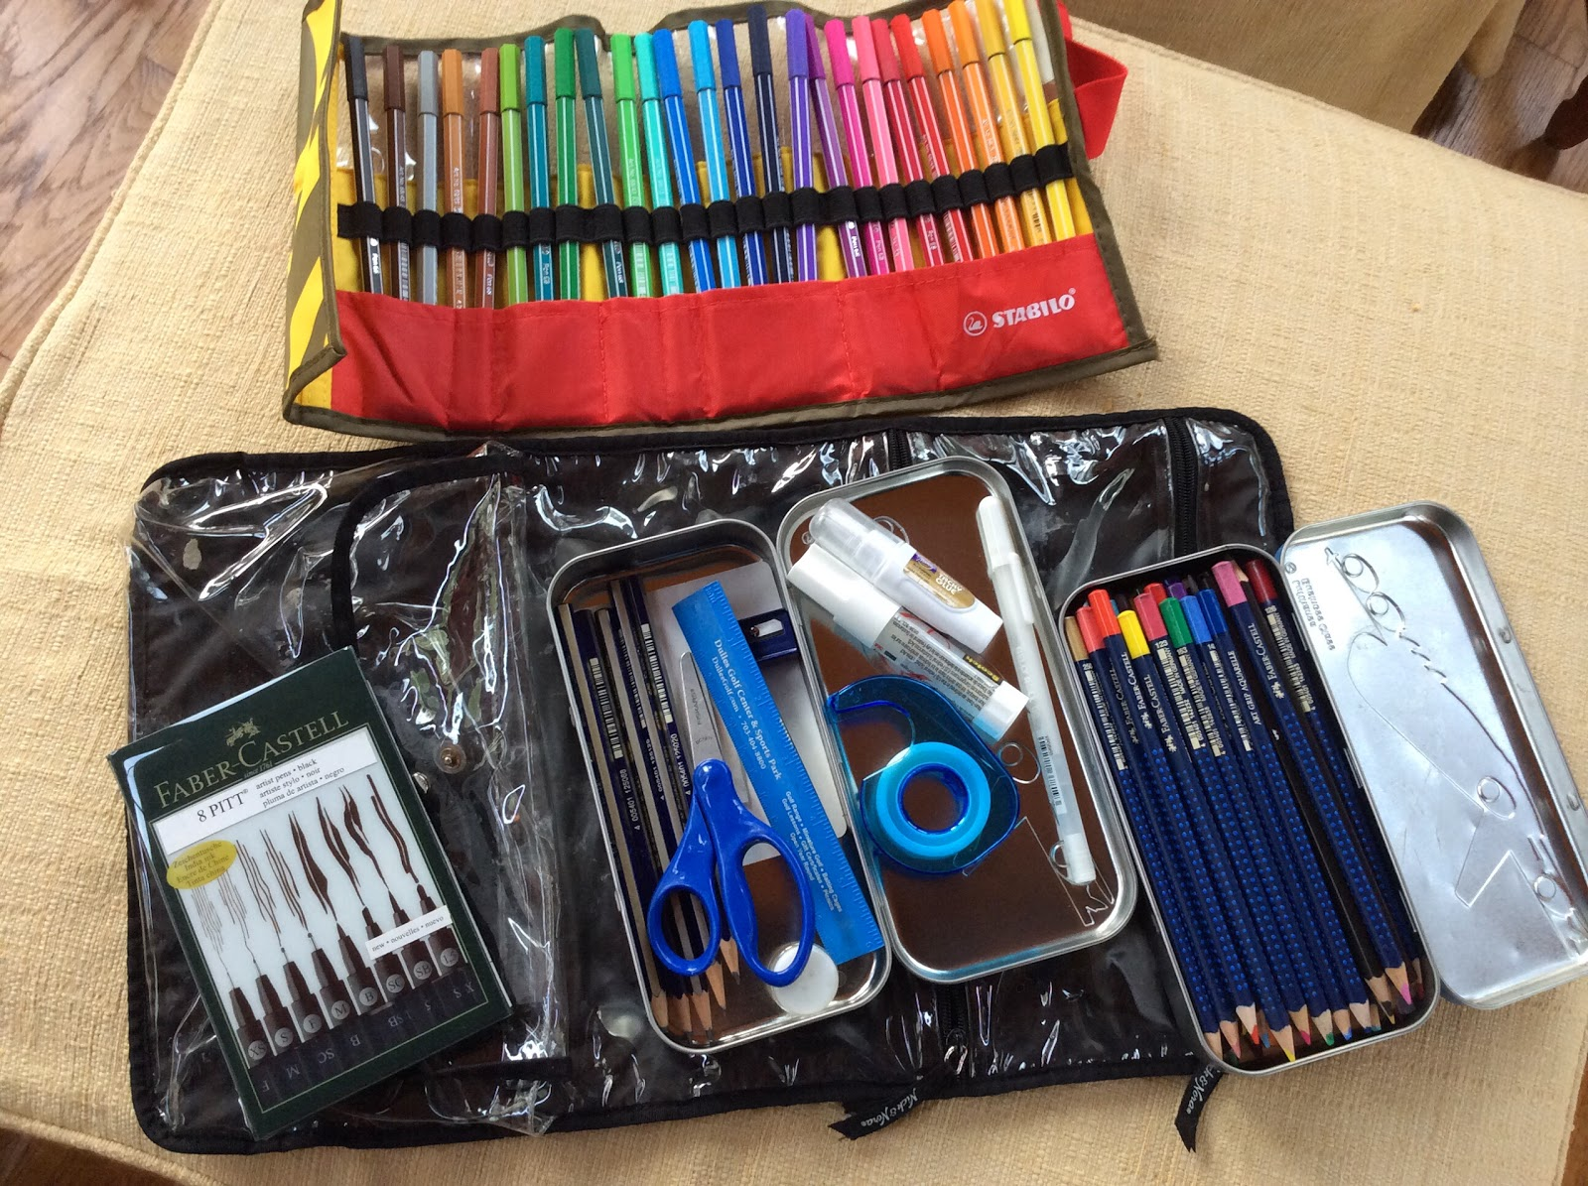

I love Faber Castell Pencils, Pitt Pens and Aquarelle Watercolor Pencils. I also love Stablio markers with their pouch to keep each marker organized. The scissors have a rounded tip so that I can bring them in my carryon on the plane.

The first picture is in the style of Matisse and the second picture is in the style of Van Gogh. The colors are a little more vibrant in the first picture because I used gel medium to seal the watercolor pencils. When I applied the gel medium, the colors ran a little. I am afraid to seal the other picture. Does anyone have any suggestions?

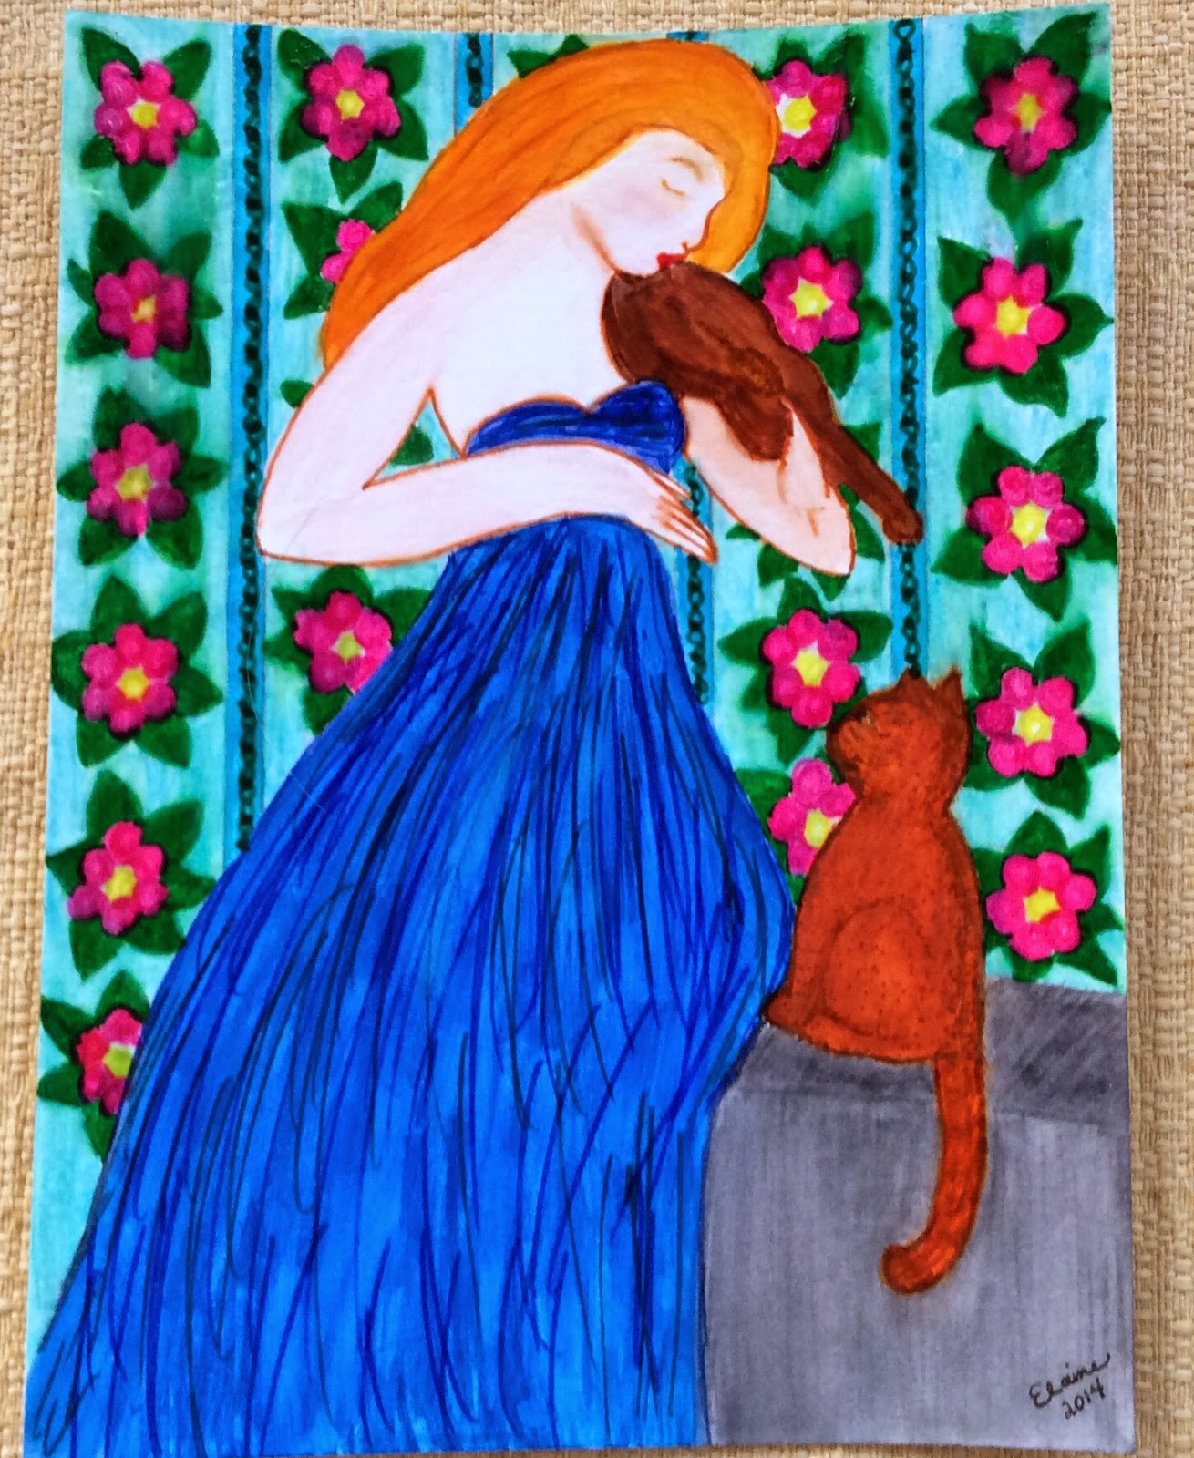

Woman with Violin

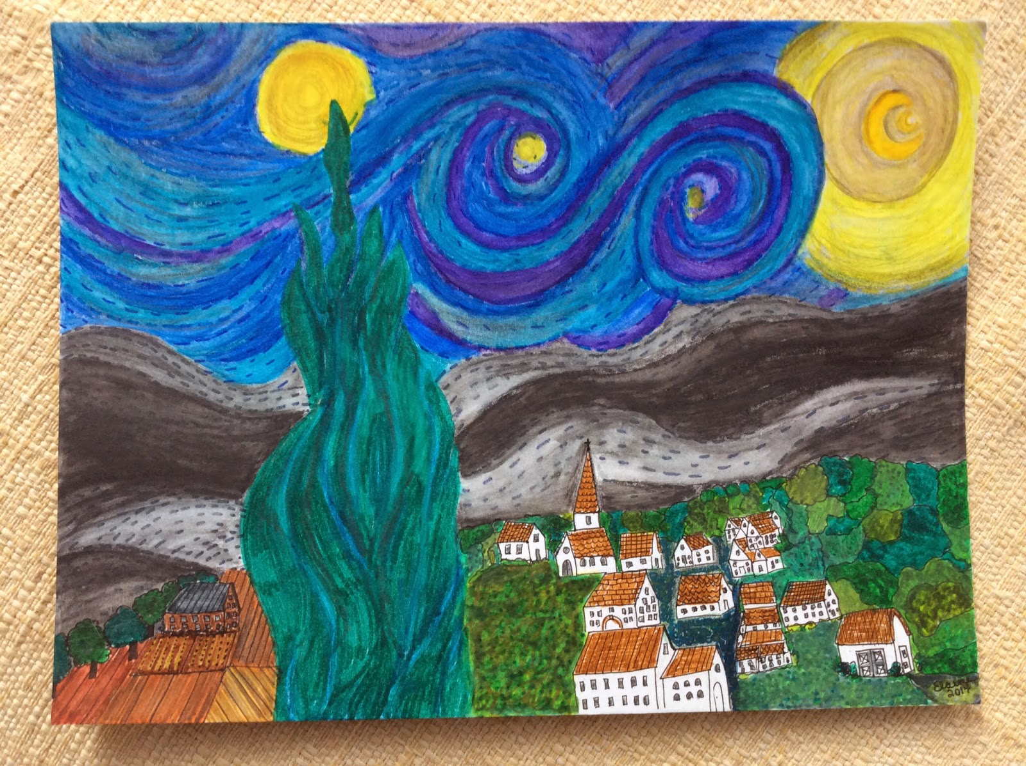

Starry Night